Spreadsheet Example 9-1.vi
Name: Baek Seunghyeon
Student no.: 3035821659
Programme: CE

This VI is an exercise in the LabVIEW Core 1 course.

This VI generates three data arrays, combines them into a 2D array, graphs them, and writes the 2D array of data to a file in spreadsheet format using the high-level file I/O function named Write To Spreadsheet File.vi.

Connector Pane


Front Panel
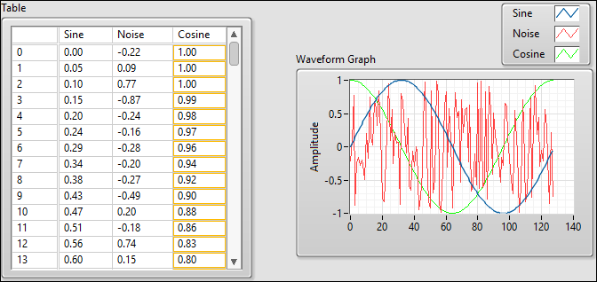

Block Diagram
